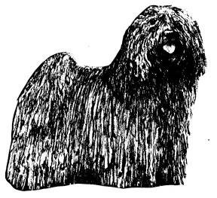
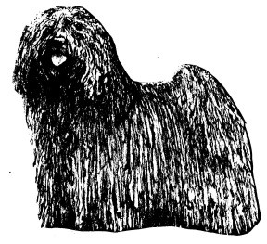
THE HUNGARIAN PULI CLUB OF GREAT BRITAIN

MEMBERSHIP APPLICATION FORM

I wish to apply for membership of The Hungarian Puli Club of Great Britain, and undertake to abide by the rules and to uphold the objects and aims of the Club.

Please print name and address
Name/s________________________________________________________

Address: ___________________________________________________________________________
Postcode: _____________________________________________________
Email: ________________________________________

Affix (as registered with the Kennel Club):

Signature of Applicant(s) (1)
(2)

Date:

The annual subscription is £15.00 single, £19.00 joint (both applicants living at the same address) for the U.K and £22.00 for Overseas members. Payment must accompany this application. Junior member £1.00 if living in same household as Joint/Single member.

Please make cheques and postal orders out to the Hungarian Puli Club of Great Britain.
Form of Payment: Cheque Cash Postal Order Bank Transfer Please indicate the form of payment you wish to use. Total:

Bank transfer to: Natwest Bank Sort Code: 60-17-28 Account No: 91309034: include your name in the reference.

The Hungarian Puli Club of Great Britain retain membership details on computer, please tick the box if you do not agree to your information being held in this way.

I the undersigned, being a fully paid up member of the Hungarian Puli Club of Great Britain, agree to act as nominator for the above applicant.
Name:

Address:

Signature of Nominator:

Postcode:

Please return this form to:
The Hon Secretary, Catherine Knight
Email: hpcofgb@gmail.com

