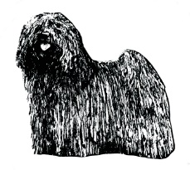
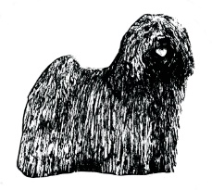
Hungarian Puli Club of Great Britain
Judges List 2018 Questionnaire

FOR NEW APPLICANTS.

Please complete the following, where applicable, and sign the declaration on the last page. You may submit by e mail and we shall accept as if signed. If you have insufficient space, please continue on an extra sheet.

To be completed and submitted to the Judges Sub Committee, prior to 27th October 2017, by all persons wishing to be considered for inclusion in the Hungarian Puli Club of Great Britain Judges Lists.

The Judges List of The Hungarian Puli Club of Great Britain is prepared annually by the Judges Sub Committee based on the application forms submitted prior to the above date.

PART 1 ALL APPLICANTS TO COMPLETE

**Please complete shaded areas only**
Title: (Mr/Mrs/Miss/Ms/Dr)
Full Name:
Address
Postcode
Telephone Number
Email Address
Affix

Please give details of all future, confirmed appointments to judge Pulis.

This enables us to provide all circulated societies with the maximum possible information.

Date: | Show:

Do you award Challenge Certificates in any other breeds? Please list below.

If you are NOT already approved to award Challenge Certificates in Pulis, please give full details of all judging you have done of the breed.

Date | Name of show | Type of show | No. of classes judged | No of dogs present & judged
TOTALS

Puli specific seminars attended, please list::

Date | Organised by | Details

Stewarding experience, please give details:

1 |  | 5 |  | 9
2 |  | 6 |  | 10
3 |  | 7 |  | 11
4 |  | 8 |  | 12

PART 2 BREED SPECIALISTS ONLY TO COMPLETE

How long have you owned Pulis?
How long have you exhibited Pulis?
Date of 1st litter bred.
Number of litters bred.
No. of Pulis bred by you in the KC Stud Book.
No. of Pulis owned by you in the KC Stud Book.
No. of other dogs owned/bred in KC Stud Book.
KC Accredited Trainer Conformation & Movement Seminar attended
KC Accredited Trainer Rules & Regulations Seminar attended

.
PART 3 NON BREED SPECIALISTS ONLY TO COMPLETE

Number of dogs bred/or owned by you in KC Stud Book.
Date of first ever judging appointment

Please list any other Working, Pastoral or “Table Breeds” owned or exhibited by you.
Other breeds judged by you at Open Show level.

Please give details of your interest in Hungarian Pulis:

PART 4 ALL APPLICANTS TO COMPLETE

Have you any other useful information that may be relevant?

DECLARATION
(To be completed and signed by all applicants. E-mail submissions will be accepted as if signed)

The submission of a completed form does not necessarily ensure inclusion in the Club’s lists.

Lists will only be valid for one year at a time and inclusion in a list in one year does not necessarily ensure inclusion in future years.

I guarantee to do a written critique for submission to the Dog Press within one month of the judging appointment. I certify that all the information I have given on this application form, is a true and accurate record.

Signature |  | Date

COMPLETED FORMS TO BE RETURNED BY 27th OCTOBER 2017 TO

Mr W Fulton
16 Seaforth Park,
Annan,
Dumfriesshire,
DG12 6HX.

Telephone: 01461 204232
e-mail: CordantePulis@aol.com

