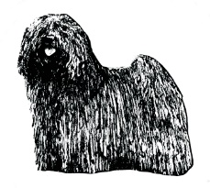
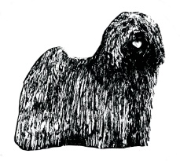
Hungarian Puli Club of Great Britain
Judges List 2018 Questionnaire

Abbreviated questionnaire to be completed and submitted to the Judges Sub Committee, prior to 27th October 2017, by all judges currently on the A1 list.
The Judges List of The Hungarian Puli Club of Great Britain is prepared annually by the Judges Sub Committee, based on the application forms submitted prior to the above date.

**Please complete shaded areas only**
Title: (Mr/Mrs/Miss/Ms/Dr)
Full Name:
Address
Postcode
Telephone Number
Email Address
Affix

Please give details of all future, confirmed appointments to award Challenge Certificates in Pulis.
If no future appointments please give last appointment judged.
This list enables us to provide all circulated societies with the maximum possible information

Date: | Show:

DECLARATION
(To be completed and signed by all applicants. E-mail submissions will be accepted as if signed)
The submission of a completed form does not necessarily ensure inclusion in the Club’s lists.
Lists will only be valid for one year at a time and inclusion in a list in one year does not necessarily ensure inclusion in future years.
I guarantee to do a written critique for submission to the Dog Press within one month of the judging appointment. I certify that all the information I have given on this application form, is a true and accurate record.

Signature |  | Date

COMPLETED FORMS TO BE RETURNED BY 27th OCTOBER 2017 TO

Mr W Fulton
16 Seaforth Park, Annan,
Dumfriesshire, DG12 6HX.

Telephone: 01461 204232
e-mail: CordantePulis@aol.com

